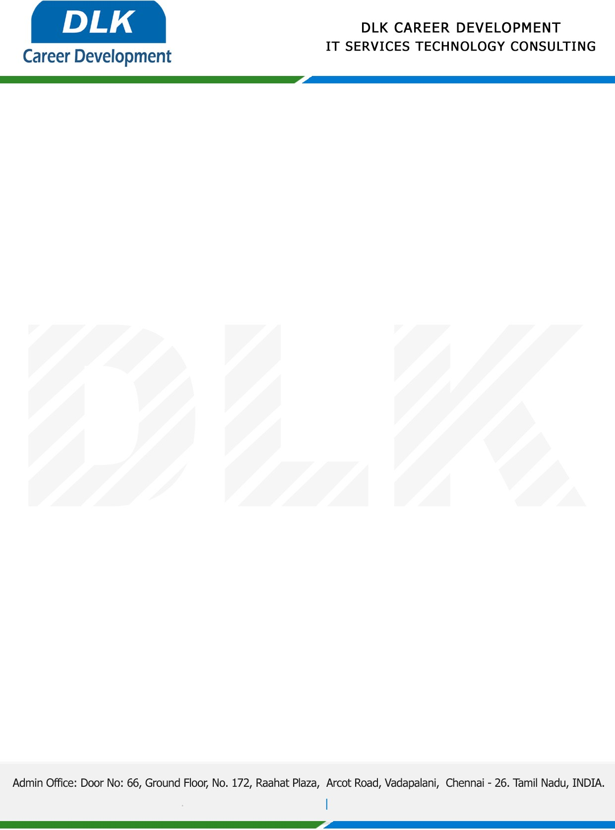

Date: 23 / December/ 2022

**To**

Department of BE –Computer Science Engineering,

Head of Department,

Velammal Engineering College, Chennai-600066.

**Sub: Letter of Internship Acceptance**

This is to certify of pre-final year student of has accepted the Internship Work duration from **26th December 2022** to **13th January 2023** under the domain **“DATA SCIENCE”.** During the internship, all information and data collected from you should be kept confidential.

**Name List:-**

1. MR GOWTHAM R (REG NO: 113220031039)
2. MS VINUNITHI G N (REG NO: 113220031167)
3. MS KARTHIKA S (REG NO: 113220031051)

We appreciate your interest in **DLK CAREER DEVELOPMENT**

